29.75: a)

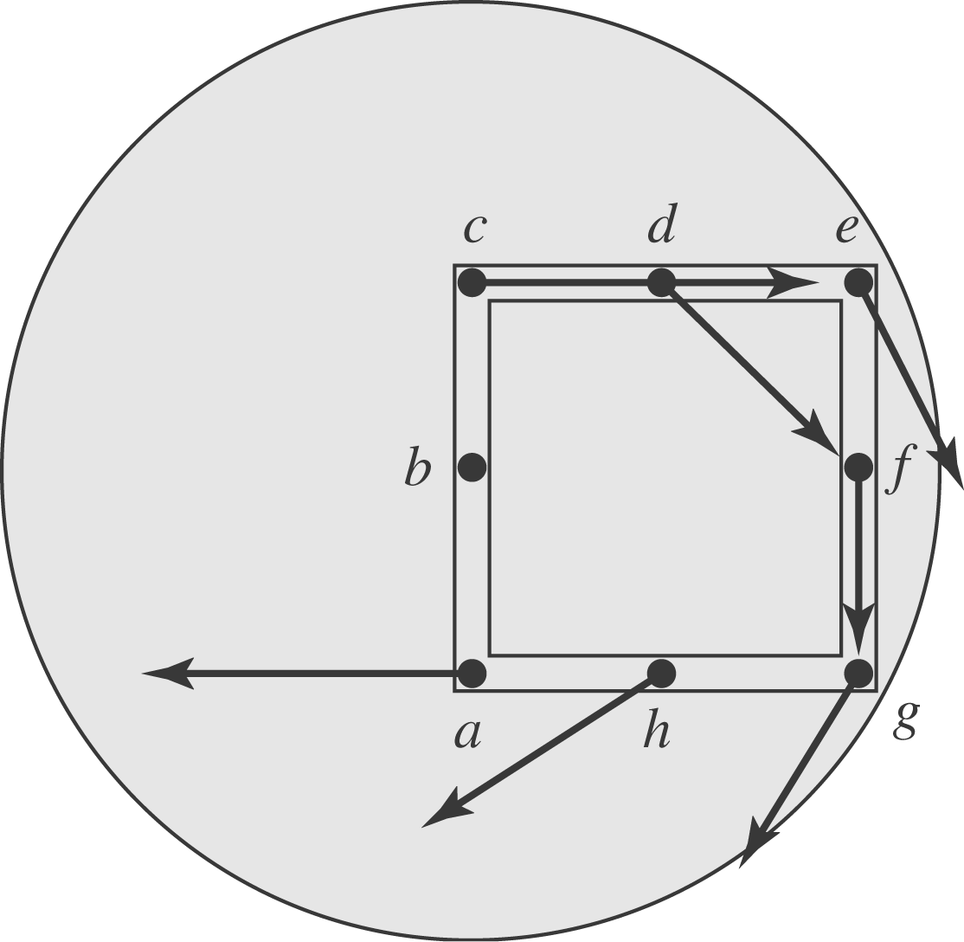

b) The induced emf on the side is zero, because the electric field is always perpendicular to the line
c) To calculate the total emf in the loop, 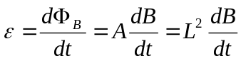
d) 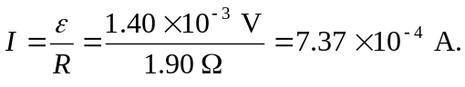
e) Since the loop is uniform, the resistance in length is one quarter of the total resistance. Therefore the potential difference between and is: and the point is at a higher potential since the current is flowing from 